Use this guide to troubleshoot registration.
Sometimes course registration doesn’t go as smoothly as you’d like. If you’ve already tried to register for courses and are experiencing problems, here are some tips on troubleshooting the process.

Instructions
- Select a course to open the View Course Section Registration screen. Click the Troubleshoot button.



- The Troubleshoot Registration screen will appear. Review the following items. If you have further questions, contact your advisor.

- If Enrollment Window = No, then your registration appointment has not yet opened or is closed. Review your registration start time displayed on your Academics homepage.

- If Holds = 0, then you have no holds on your account and can register. Some holds will prevent you from registering. If you have holds, view and resolve them from the Academics app homepage.

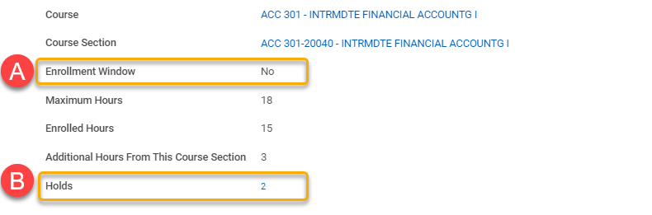

- In the Course and Course Sections tables, review the Can Register column. If all rows = Yes, there are no registration issues. If any rows display No, read below for a brief description of the most common issues.

- If Eligible = No, then you do not meet the prerequisites for the course. Review the Details column for more information. To enroll, request a prerequisite override from the instructor through the Academics homepage.

- If Access to Enrollment = No, then you do not have access to registration. Contact your advisor or the registrar.

- If No Time Conflict Exists = No, then you are currently enrolled in a course section with an overlapping meeting time. To resolve, you must drop the course section with the time conflict.

- If No Duplicate Registrations = No, then you have already taken the course or are currently enrolled in the course.

- If Has Capacity = No, then the course if full. If a waitlist is available, add yourself to the waitlist.

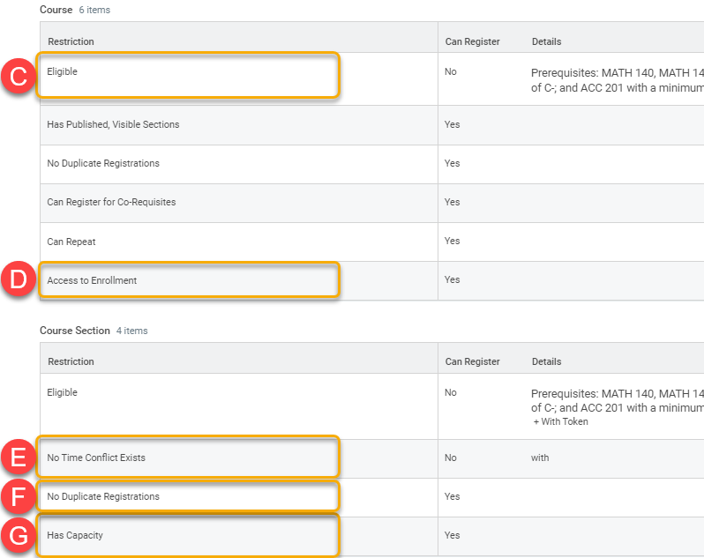
If you need help resolving registration issues, contact your advisor or the registrar for help.

